Team leader name : محمود ثروت دايدامون عبد الكريم
id : 20240895
CPU Scheduling Simulator
Round Robin · Shortest Remaining Time First

1 · Project Overview

1.1 Description
This project is a desktop-based CPU Scheduling Simulator developed in Java using the JavaFX framework. It implements and visually compares two well-known CPU scheduling algorithms: Round Robin (RR) and Shortest Remaining Time First (SRTF). The simulator accepts a set of user-defined processes — each with an arrival time and a burst time — runs both algorithms simultaneously against that input, and presents the results side by side in a rich graphical interface.

1.2 Purpose
The primary goal of this project is educational. CPU scheduling is a foundational topic in Operating Systems, and understanding the trade-offs between different algorithms is essential for any computer science student or practitioner. Rather than analysing these algorithms through static textbook tables, this simulator lets the user interact with live data, observe the Gantt chart execution order in real time, and draw concrete conclusions from the numeric comparison automatically generated by the system.

1.3 Key Features
- Dual-algorithm simulation — both RR and SRTF run on the same process set and results are displayed side by side.
- Visual Gantt Charts — colour-coded, scrollable Gantt charts rendered on a JavaFX Canvas for each algorithm.
- Per-process metrics — Completion Time, Turnaround Time (TAT), Waiting Time (WT), and Response Time (RT) are computed and shown in sortable TableView grids.
- Averaged summary row — an automatically appended AVG row makes it trivial to compare aggregate performance.
- Comparison Summary panel — a textual analysis identifies which algorithm won each metric and provides a contextual recommendation.
- Ready Queue Log — a step-by-step trace of the RR ready queue state is displayed after each scheduling tick.
- Five preset scenarios — buttons A through E load carefully designed test cases covering mixed workloads, quantum sensitivity, short-job preference, fairness, and input validation.
- Full input validation — the system catches bad quantum values, missing PIDs, and invalid arrival/burst times with descriptive dialog messages, without forcing a restart.
- Dynamic process table — rows can be added, deleted individually, or cleared in bulk at any time.

2 · System Architecture

2.1 High-Level Overview
The application follows the Model-View-Controller (MVC) architectural pattern. This separation of concerns means the scheduling logic is entirely independent of the UI, making each component testable and maintainable in isolation.

2.2 Components / Modules

Package | Class | Responsibility
com.scheduler | App | JavaFX entry point; creates the stage and wires view + controller
com.scheduler.controller | MainController | Reads UI state, validates input, invokes schedulers, pushes results back to view
com.scheduler.model | Process | Data class holding PID, arrival, burst, and all computed metrics
com.scheduler.model | GanttEntry | Immutable record of a single Gantt block (processId, start, end)
com.scheduler.model | SimulationResult | Bundles the completed process list, Gantt entries, optional RQ log, and pre-computed averages
com.scheduler.model | RoundRobinScheduler | Pure-logic RR simulation; takes a process list + quantum, returns a SimulationResult
com.scheduler.model | SRTFScheduler | Pure-logic SRTF simulation; takes a process list, returns a SimulationResult
com.scheduler.view | MainView | Entire JavaFX UI — input panel, scenario bar, Gantt chart areas, metrics tables, summary area
com.scheduler.view | GanttChartPane | Custom Pane that owns a Canvas and draws colour-coded Gantt blocks with time ticks

2.3 Component Interaction
- App.java instantiates MainView and MainController, passing the view reference to the controller.
- The controller registers two callbacks on the view: onRunSimulation and onLoadScenario.
- When the user clicks ▶ Run Simulation, the view fires onRunSimulation. The controller reads the quantum and process rows from the view, validates them, then calls RoundRobinScheduler.simulate() and SRTFScheduler.simulate() sequentially.
- Both schedulers operate on deep copies of the process list, so the original input data is never mutated between runs.
- The schedulers return SimulationResult objects. The controller passes both results to view.displayResults().
- MainView renders the Gantt charts via GanttChartPane.draw(), populates both TableView grids, updates the Ready Queue Log text area, and writes the Comparison Summary.

3 · Scenarios

The system ships five preset scenarios accessible from the scenario bar. Each is designed to demonstrate a different scheduling characteristic.

Scenario A — Mixed Workload
A realistic mix of processes with different arrival times and varying burst lengths. This is the most common classroom example for comparing RR and SRTF.

PID | Arrival Time | Burst Time
P1 | 0 | 8
P2 | 1 | 4
P3 | 2 | 9
P4 | 3 | 5

Parameter | Value
Time Quantum (RR) | 3

Round Robin assigns each process a maximum of 3 time units per turn and re-queues it if unfinished. Newly arrived processes are admitted to the ready queue at the end of each slice. SRTF scans all arrived, unfinished processes at every tick and runs whichever has the least remaining burst time.
Expected: SRTF yields lower average waiting time. RR provides more balanced response time, since no process waits more than (n−1) × q before its first turn.

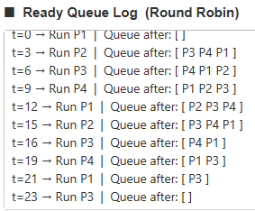
Scenario A — Input configuration

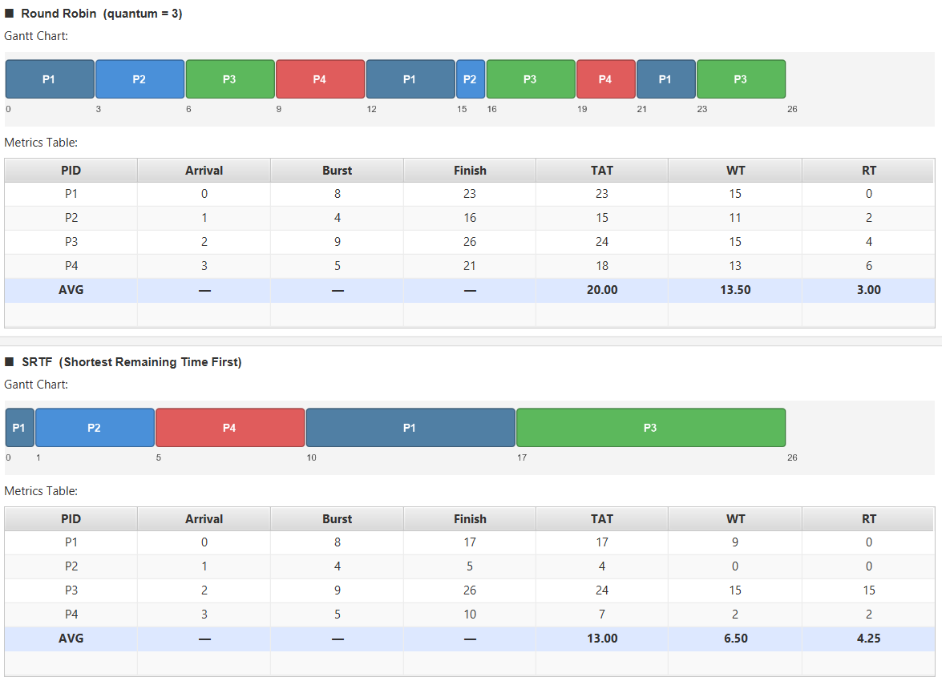
Scenario A — Simulation output with Gantt charts

COMPARISON SUMMARY — Scenario A
Metric RR (q=3) SRTF
─────────────────────────────────────────────
Avg Waiting Time 13.50 6.50
Avg Turnaround Time 20.00 13.00
Avg Response Time 3.00 4.25
─────────────────────────────────────────────
► Better Avg Waiting Time : SRTF
► Better Avg Turnaround : SRTF
► Better Avg Response Time : Round Robin

ANALYSIS
Fairness:
Round Robin cycles processes every q=3 units, ensuring
no process waits more than (n-1)×q before its next turn.
SRTF can starve long processes when short ones keep arriving.
Quantum Effect (q=3):
Smaller q → more context switches, better response time.
Larger q → fewer switches, approaches FCFS behaviour.
Short-job preference:
SRTF minimises average waiting time by always running the
process closest to completion.

CONCLUSION
✔ SRTF achieved lower avg waiting time — more efficient.
✔ Round Robin gave equal or better first response time.
✔ Round Robin is fairer: every process runs within q=3 ticks.
Recommendation:
→ SRTF for batch / throughput-oriented workloads.
→ Round Robin for interactive / time-sharing systems.

Scenario B — Quantum Effect
All four processes arrive simultaneously at time 0. This eliminates the arrival-time variable and isolates the effect of the quantum on RR behaviour.

PID | Arrival Time | Burst Time
P1 | 0 | 10
P2 | 0 | 5
P3 | 0 | 3
P4 | 0 | 7

Parameter | Value
Time Quantum (RR) | 4

With a quantum of 4, RR runs each process for up to 4 time units before switching. SRTF immediately picks P3 (burst=3) first, then P2, then P4, then P1 — ordering by shortest burst since all are available from t=0. Expected: SRTF significantly outperforms RR in average waiting time and TAT because it finishes short processes early.

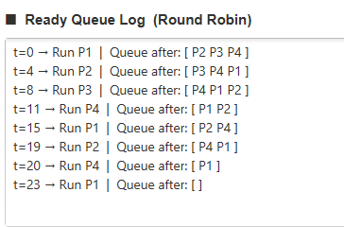
Scenario B — Input configuration

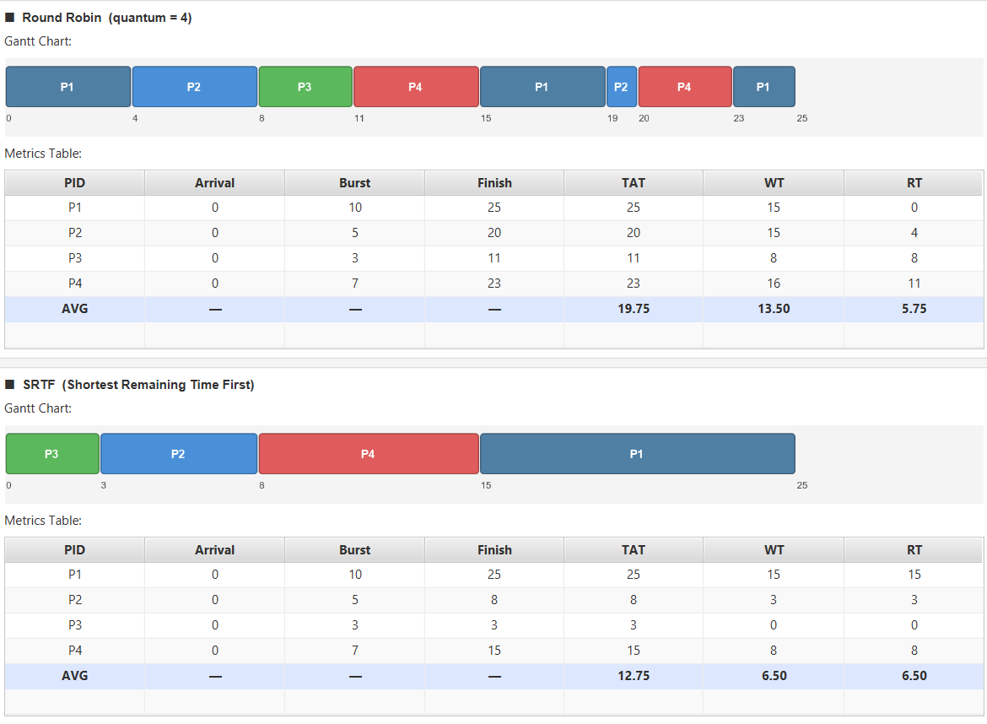
Scenario B — Simulation output with Gantt charts

COMPARISON SUMMARY — Scenario B
Metric RR (q=4) SRTF
─────────────────────────────────────────────
Avg Waiting Time 13.50 6.50
Avg Turnaround Time 19.75 12.75
Avg Response Time 5.75 6.50
─────────────────────────────────────────────
► Better Avg Waiting Time : SRTF
► Better Avg Turnaround : SRTF
► Better Avg Response Time : SRTF

CONCLUSION
✔ SRTF achieved lower avg waiting time — more efficient.
✔ SRTF gave better first response time here.
✔ Round Robin is fairer: every process runs within q=4 ticks.
Recommendation:
→ SRTF for batch / throughput-oriented workloads.
→ Round Robin for interactive / time-sharing systems.

Scenario C — Short Jobs Mix
Six small processes arrive in two waves. This tests how each algorithm handles rapidly arriving short tasks.

PID | Arrival Time | Burst Time
P1 | 0 | 2
P2 | 0 | 1
P3 | 1 | 3
P4 | 1 | 1
P5 | 2 | 2
P6 | 2 | 1

Parameter | Value
Time Quantum (RR) | 2

With q=2 and most burst times ≤ 2, RR acts almost like FCFS for the shortest processes. SRTF will continuously preempt in favour of newly arrived shorter processes. The Gantt charts here tend to look very similar between algorithms.

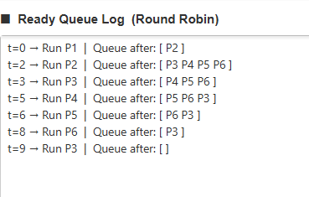
Scenario C — Input configuration

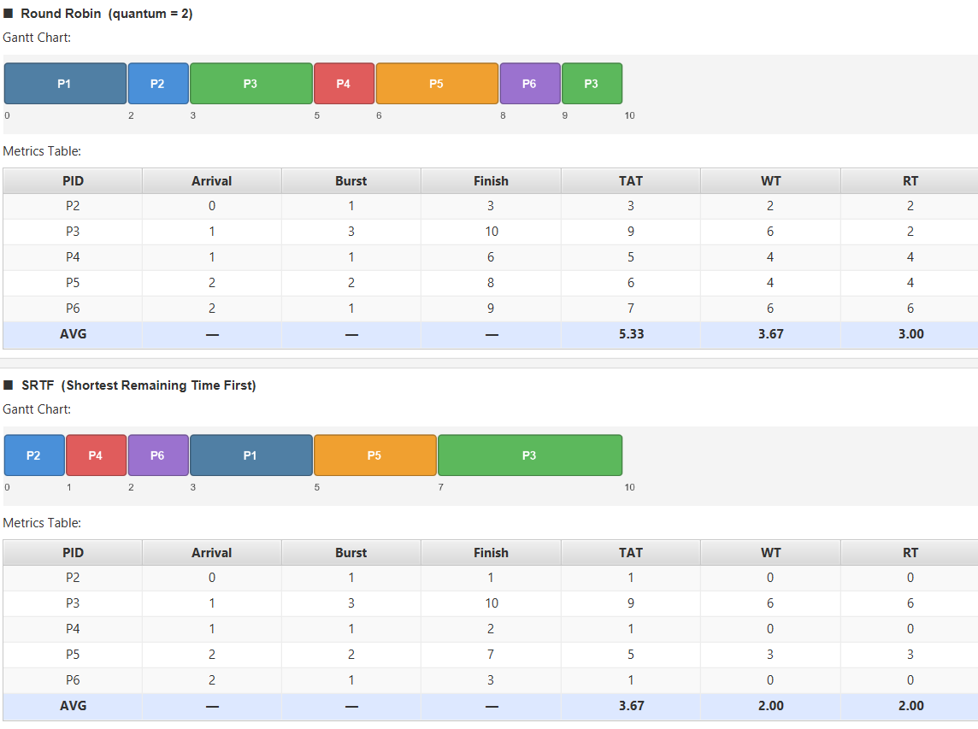
Scenario C — Simulation output with Gantt charts

Scenario D — Fairness Test
Four processes all arrive at t=0 with equal burst times. This is the fairness stress test — both algorithms should produce symmetric results.

PID | Arrival Time | Burst Time
P1 | 0 | 6
P2 | 0 | 6
P3 | 0 | 6
P4 | 0 | 6

Parameter | Value
Time Quantum (RR) | 2

Key Insight
RR is strictly fairer than SRTF when burst times are equal, because SRTF tie-breaking can favour certain processes. RR cycles P1→P2→P3→P4 equally; SRTF defaults to arrival order.

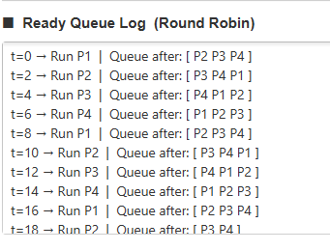
Scenario D — Input configuration

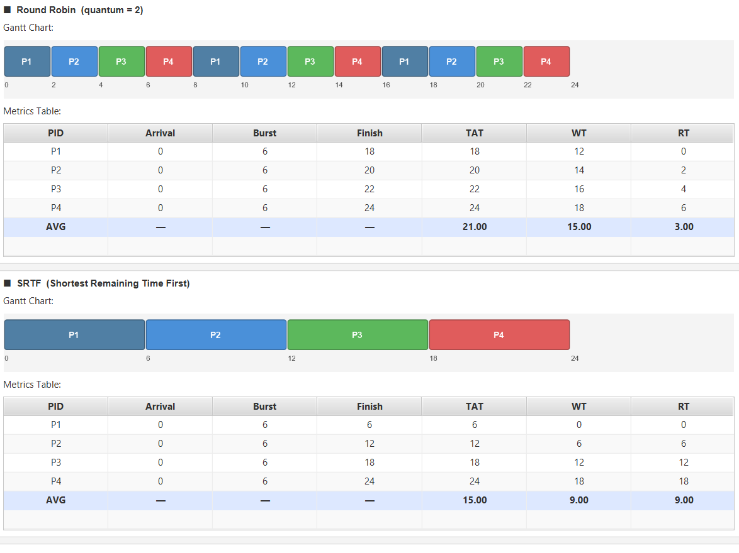
Scenario D — Simulation output with Gantt charts

Scenario E — Input Validation
This scenario is intentionally loaded with an invalid time quantum of −1. It demonstrates the system's error-handling mechanisms.

PID | Arrival Time | Burst Time
P1 | 0 | 5
P2 | 2 | 3

Parameter | Value
⚠ Time Quantum (RR) | −1 (intentionally invalid)

When the user clicks ▶ Run Simulation, the controller catches the bad quantum and displays an Alert.ERROR dialog. No simulation is run; all UI state is preserved so the user can correct the value and retry without re-entering data.

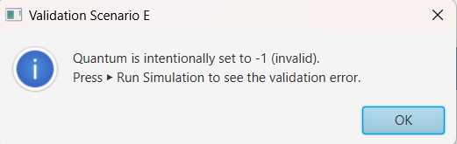

4 · Input Validation & Error Handling

4.1 Quantum Validation
The system applies a two-layer validation strategy: field-level checks at the view layer and semantic checks at the controller layer.

4.2 Process Row Validation

Condition | Error Message
PID field empty (other fields filled) | A process is missing its PID.
Arrival time is not an integer | Arrival time for 'X' must be a non-negative integer.
Burst time is not an integer | Burst time for 'X' must be a positive integer.
Arrival time < 0 | Arrival time for 'X' cannot be negative.
Burst time ≤ 0 | Burst time for 'X' must be greater than 0.
Duplicate PIDs | Duplicate process ID 'X'. Each process must have a unique ID.

Completely blank rows (all three fields empty) are silently skipped — this avoids false errors when rows are partially used.

4.3 Edge Cases

Edge Case | Handling
Quantum = 1 | Valid; maximum context switches, approaches SRTF-like behaviour in RR
Single process | Valid; both algorithms produce the same result trivially
All same burst | Valid; fairness scenario (see Scenario D)
Process arrives after all others finish | Handled via idle-gap logic in both schedulers

5 · Implementation Details

5.1 Technology Stack

Technology | Version | Role
Java | 17 (LTS) | Primary implementation language
JavaFX | 21.0.2 | Desktop UI framework (controls, canvas, layout)
Apache Maven | 3.x | Build system and dependency management
JavaFX Maven Plugin | 0.0.8 | Launches the JavaFX app via mvn javafx:run

5.2 Round Robin Algorithm
The RR implementation uses a LinkedList<Integer> as the ready queue, storing process indices. Key steps of the core loop:
- Seed the queue — all processes with arrivalTime == 0 are enqueued at startup.
- Dequeue the front process index.
- Record first response — if firstResponseTime is still −1, capture the current time.
- Run for min(quantum, remaining[idx]) ticks and advance the clock.
- Admit new arrivals — scan all unfinished, not-in-queue processes and enqueue those whose arrivalTime ≤ currentTime.
- If the process finished, mark it done. Otherwise, re-enqueue it at the back.
- CPU idle gap — if the queue is empty, advance the clock to the next earliest arrival.
- Ready Queue Log — after each scheduling decision, append a snapshot string for display.

5.3 SRTF Algorithm
SRTF is implemented as a tick-by-tick simulation (time advances by 1 each iteration):
- At each tick, scan all arrived, unfinished processes and select the one with the smallest remaining time.
- On a context switch, flush the previous process's accumulated slice into the Gantt list as a single GanttEntry.
- Decrement remaining[chosen] by 1 and advance the clock by 1.
- If a process finishes (remaining == 0), flush its final Gantt slice and record metrics.
- IDLE gaps — if no process has arrived yet, an explicit 'IDLE' Gantt entry is inserted for that tick.

The tick-by-tick approach O(n × totalBurst) is acceptable for educational scenarios with small process counts and is the clearest way to model preemptive behaviour accurately.

Conclusion

The project delivers a fully functional, visually rich desktop simulator that implements and compares Round Robin and SRTF CPU scheduling algorithms.

Finding | Detail
Finding 1 | SRTF consistently achieves lower average waiting time by always prioritising the process with the least remaining work.
Finding 2 | Round Robin guarantees bounded response time and fairness, making it the natural choice for interactive, time-sharing environments.
Finding 3 | The quantum value in RR is a critical tuning parameter — small values approach SRTF efficiency at the cost of context switch overhead; large values approach FCFS.

The simulation demonstrates a clear trade-off between efficiency and fairness in CPU scheduling algorithms, where SRTF minimizes waiting time while Round Robin ensures equitable CPU distribution among processes.

